Quick Reference Guide Mitel Communications Director

MITEL 5340 IP PHONE
NOTE: For more information about using other features and applications on your 5340 IP Phone, refer to 5330/5340 IP Phone User Guide located at www.mitel.com, or contact your Administrator. SIP Users: Refer to the 5330/5340 SIP User and Administrator Guide.

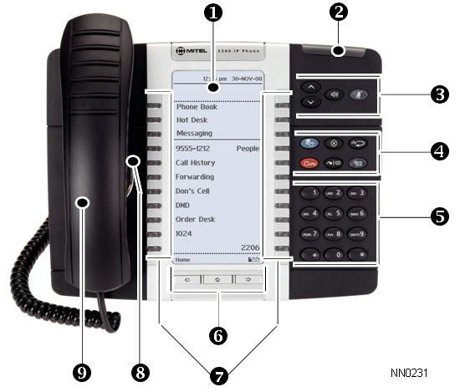
Make a Call
- Lift the handset OR
❸ Press .
❺ Dial the number OR
❼ Press a Speed Call key OR
❹ Press OR
❺ Dial the prefix for external calls (e.g. 9) and the number.

Answer a Call
- Lift the handset OR

Transfer a Call
❹ Press .
❺ Dial the number. Wait for an answer.
- Hang up OR wait for the called party to answer, announce the transfer, and then hang up.

Conference a Call
❹ Press .
❺ Dial the number of the next party. Wait for an answer.
❹ Press .

❸ Press , and begin speaking.

Program a Speed Call

❶ | Display | Speaker
❷ | Ring/Message Indicator | Mute
❸ Volume, Speaker, Mute Controls Menu
❹ Fixed Function Keys Cancel
❺ Keypad Redial
- Page Navigation Keys Hold

End a Call
❹ Press OR
- Replace the handset.

Place a Call on Hold
❹ Press . The line key flashes.
- Replace the handset if necessary.

Retrieve a Call from Hold
- Lift the handset OR
❸ Press .
❼ Press the flashing line key.
❹ Press Menu OR .
Press Settings.
Press Programmable Keys.
Press the key you wish to program. Press Speed Call.
Press Edit Info and enter the label for the Speed Call.
Press Save.
Press Edit Number and enter the phone number for the Speed Call.
Press Save, and then press Save again. Press Close and then press Close again.

Adjust Volume Levels
Adjust ringer volume while the phone is ringing.

❼ Programmable Feature Keys and Softkeys Transfer/Conference
Adjust handset or speaker volume while using the

❽ Speaker Message
- Handset

Retrieve a Message
❹ Press . It flashes when a message is waiting.
Follow the voice mail prompts to retrieve your message.
handset or speaker.
❸ Press repeatedly to raise the volume OR repeatedly to lower the volume.
❸ Press to mute your microphone.

M Mitel (design) is a registered trademark of Mitel Networks Corporation. All other products and services are the trademarks of their respective holders.
© 2012, Mitel Networks Corporation. All rights reserved.

NuPoint Voicemail Set-Up
Accessing Your Mailbox
All of your voice messages will reside in your personal mailbox, which is passcode protected. Your temporary passcode will be 1111 to use the first time you access your mailbox. How you log into your mailbox will depend on whether you’re calling from inside or outside your company.
From Your Own Extension
- Press the (MESSAGE) key on the Mitel phone
- Enter your passcode when prompted.
From Another Extension
- Press the (MESSAGE) key on the Mitel phone
- Press the key when prompted to enter a passcode
- Enter your mailbox number followed by the key.
- Enter your passcode when prompted.
Note: You may need to use this procedure to access a general mailbox when the lamp is inactive.
Setting Up Your Mailbox
When you access your mailbox for the first time, a user tutorial automatically activates. This tutorial guides you through your first mailbox session, explains how to record a greeting and your name, and prompts you to change your temporary passcode.
Passcode
- You will always be prompted for your passcode before accessing your mailbox. The first time you access your mailbox, you will use the temporary passcode 1111. During the tutorial, you will be prompted to change your passcode to a number containing 4 to 10 digits. Define a passcode that you can easily remember, but do not select an obvious code like "1234".
Greeting
- After opening your mailbox, you will be asked to record a greeting that callers will hear when they are directed to your mailbox.
- e.g. "You have reached the mailbox of Steve Smith, I’m unable to take your call, please leave me a message with your contact details and I will return your call when I am available."
Name
- You will be prompted to record your name
- The system will use this name to identify you to callers in your own voice.
Playing Messages
When you access your mailbox to retrieve your messages, the system tells you how many messages you have ("You have 2 urgent messages and 2 un-played messages.").

Playing Your Messages
- After accessing the Voice Mail menu, press 7 to listen to your messages. Your urgent messages will automatically be played first. Then, your un-played messages will be played.

